Answers
Task 1
The table below shows four sensors. Identify the name of each sensor from the following:
Push button, oxygen sensor, cooking thermometer, ultrasonic sensor
Sensor | Sensor name
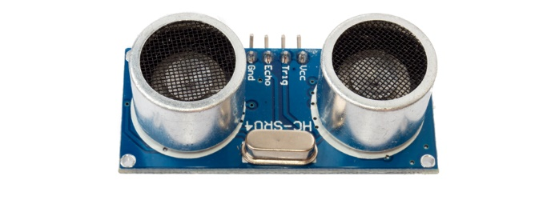 | Ultrasonic sensor
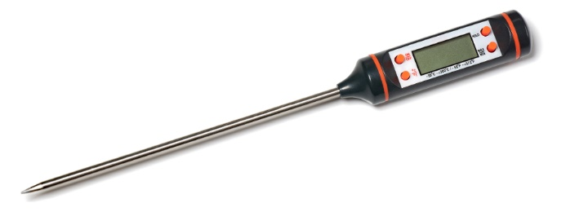 | Cooking thermometer
 | Push button
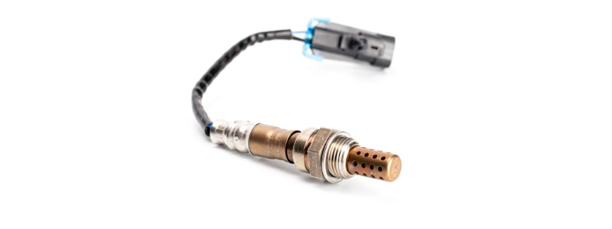 | Oxygen sensor

Task 2
Research three other sensors and for each one give an example of an automated system that may use it.
Sensor name | Image of the sensor | Example of where it may be used
Smoke detector sensor  (The sensor shown is an ionisation sensor – it contains radioactive material. Smoke prevents the flow of ions reducing current and activating the alarm. An alternative sensor is a photoelectric (optical) sensor) | 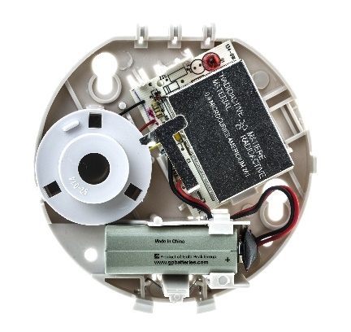 | Smoke alarm system
Touch sensor | 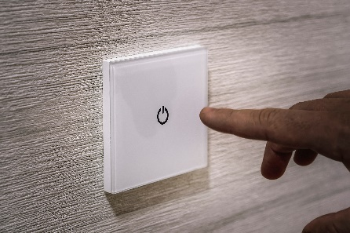 | Light switch
Passive infra-red (PIR) sensor | 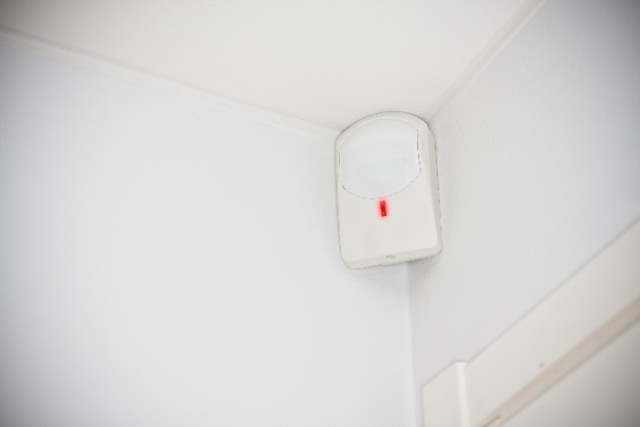 | Alarm system
Three examples are given in the above table. Students may choose from a myriad of other sensors.
For more able students, ask them to explain how the sensor works.

Task 3
Lighting is one area that can be controlled by automated systems.
(a) Explain three sensors and how they could be used to control a lighting system.
Sensor 1:
Sensor 2:
Sensor 3:
Examples include:
Light sensor (e.g. on a car) used to turn on headlights when it is dark.
Touch sensitive button to turn on a light in a house when it is pressed.
Microphone to sense instructions to a smart assistant (that then turns on a light).
Clock (internal clock on a computer/automated system) that turns on/off a light at a pre-programmed time.

(b) A farmer has automated lighting for a greenhouse that is used to grow lettuces. The lights need to turn on between the hours of 4pm and 11pm in the winter and 9pm and 11pm in the summer. The lights also need to turn if it is cloudy – this is detected by a light sensor reading of less than 5.
Develop an algorithm using pseudocode or English sentences for the automated lighting system.
An example of an algorithm in pseudocode:
currentLight ← CALL GetLightValue()
hour ← CALL GetHour()
season ← GetSeason()
lightState ← FALSE
IF currentLight < 5
THEN
lightState ← TRUE
IF season = "Winter" AND time >= 4 AND time <= 11
THEN
lightState ← TRUE
ELSE
IF season = "Summer" AND time >= 9 AND time <= 11
THEN
lightState ← TRUE
ENDIF
ENDIF

Task 4
Work in a pair or small group. Choose one topic from the following topics:
Agriculture Weather Science
Your chosen topic: ___
Research your chosen topic to answer the following questions:
(a) Choose one specific area where automation is used in your topic area and write it below:
Examples could include weather stations (weather), lab automation for the testing of samples (science) or self-driving tractors based on GPS (agriculture).
Some videos that may help students include:
https://www.youtube.com/watch?v=2ORzUhhBe9Q (lab automation example video)
https://www.youtube.com/watch?v=ZFDsqC_JJYU (GPS tractor automation)
https://www.youtube.com/watch?v=2HK63sjvvh4 (The science behind the MET office)

(b) Describe how automation is carried out. Remember to include any sensors that may be used in the automation.
Answers will depend on the applications that students have chosen.
(c) Give at least three advantages of the automation that you have chosen.
Answers will depend on the applications that students have chosen.
Typically, answers will mention that fewer people are involved, or that the process is more efficient or more accurate in some manner.
(d) Give at least two disadvantages of the automation that you have chosen.
Answers will depend on the applications that students have chosen.
Typically, answers may mention job losses, reduced opportunities (especially in the type of work that automation replaces) and the cost of implementing automated solutions.

